Assignment 21.3 Ai Assisted Coding
Htno:2303a510C0
Btno:06
Task 1: AI-Assisted Expense Tracker Application using Python
Prompt: Generate a basic Python program to record daily expenses with amount and category. Then improve it by adding monthly summary, input validation, and modular functions Code:
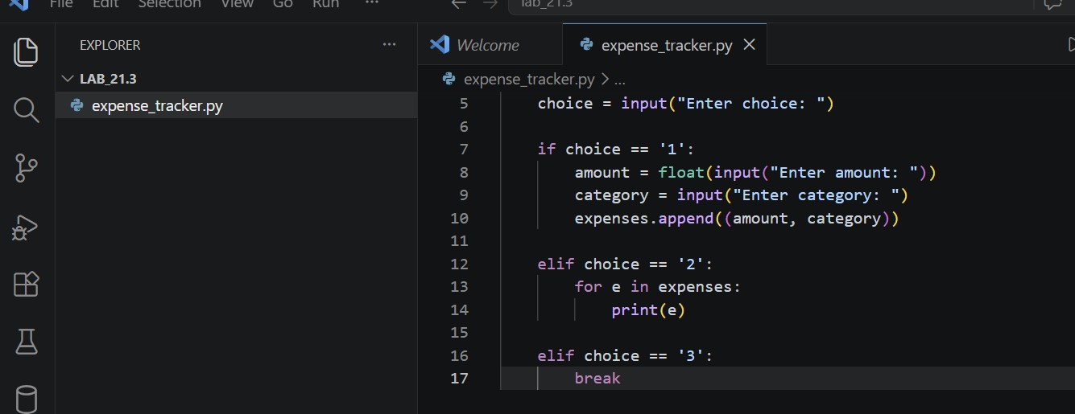
Output:
• 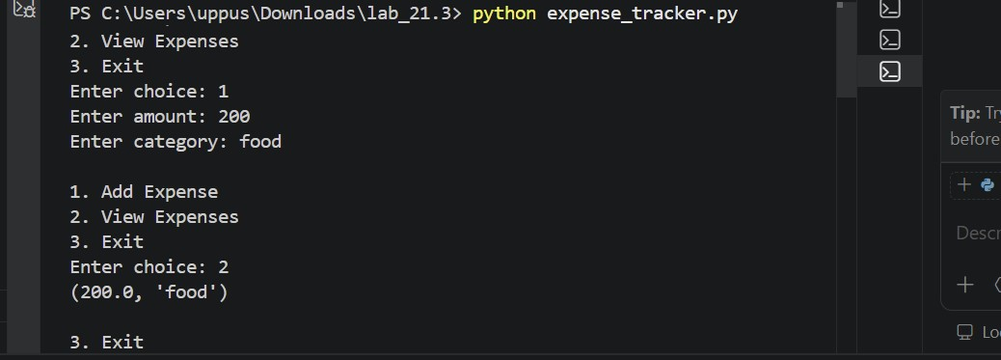
The program stores expenses in a list
- User can:
- Add expense (amount + category)
- View expenses Corrtected Code:
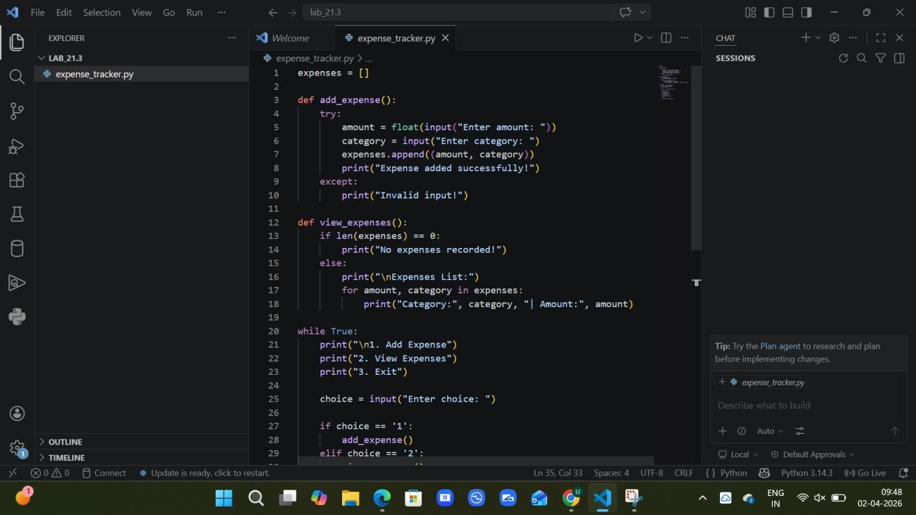
Output:
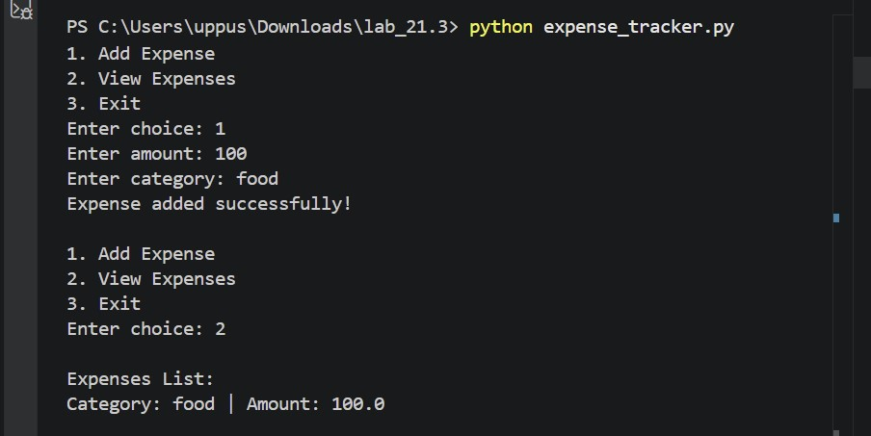
Explanation:
- Code is divided into functions:
- add_expense() → adds expense
- view_expenses() → displays expenses
- Added input validation using try-except
- Displays user-friendly output format
- Shows message when no data is available

Task 2: Version Control Integration using Git – Student Grade Calculator
Prompt: Create a Python program to calculate average marks. Then enhance it using AI by adding grade classification and percentage calculation, and manage the project using Git with branching and merging."
Code: Initial Code
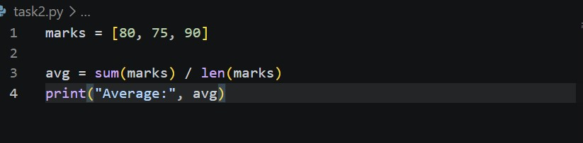
Output: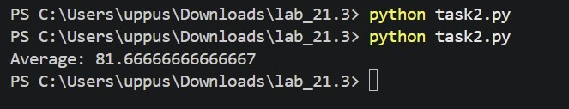Explanation:
- Stores marks in a list
- Calculates average using sum() and len()
- Displays only average Corrected Code:
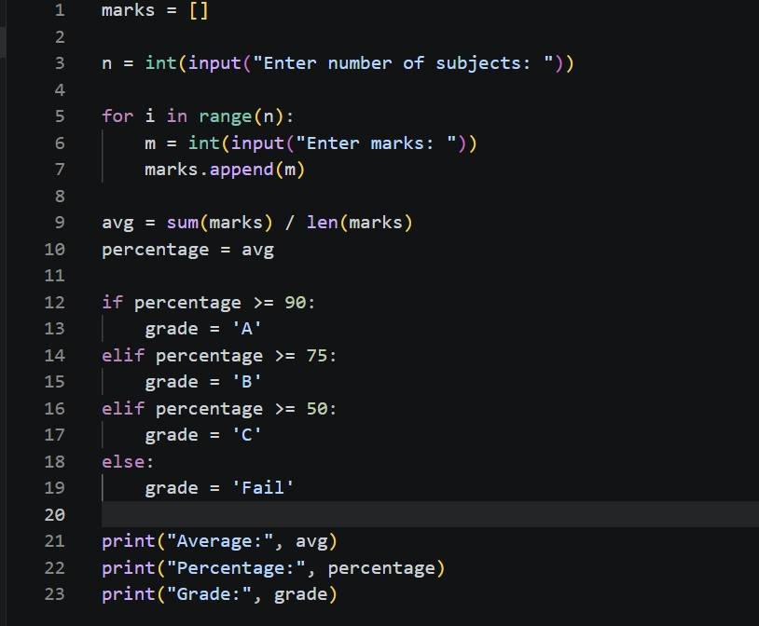
Output:
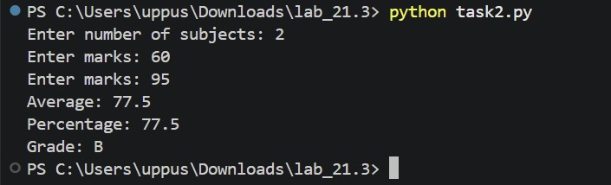
Explanation:
- Takes user input for marks
- Calculates: o Average o Percentage
- Assigns grade based on percentage
- Uses conditional statements for classification
- More realistic and user-friendly

Task 3: Password Validation Module with AI-Generated Commit Messages
Prompt: Create a Python program to validate a password with rules like minimum length and special character requirement. Also generate meaningful commit messages for the updates.
Code: Initial Code
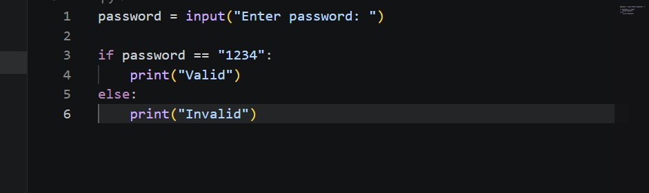
Output:
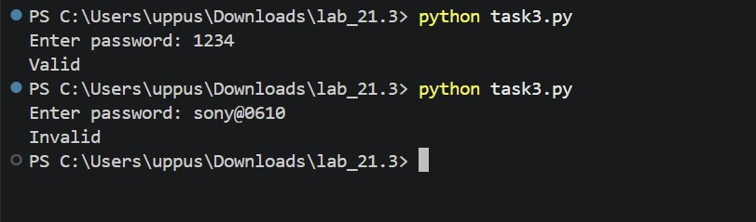
Explanation:
- Takes password input from user
- Checks only one fixed password ("1234")
- Prints valid or invalid Corrected Code:
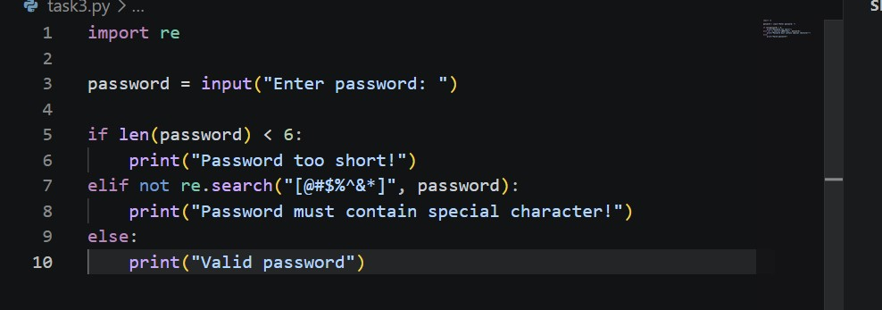
Output:
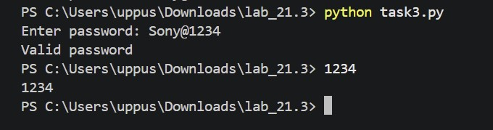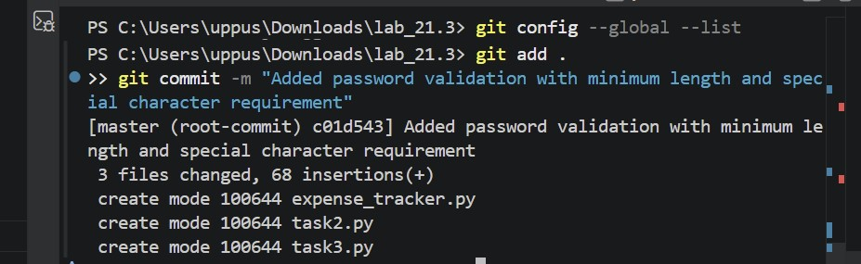

Explanation:
- Uses regular expressions (re module)
- Checks:
- Minimum length (6 characters)
- Special character requirement
- More secure and realistic
- Provides meaningful messages

Task 4: Quiz Management System using Pair Programming with AI Assistance and
Git Integration
Prompt: Create a simple quiz program with questions and answers. Then enhance it using AI by adding score calculation and input validation. Simulate collaboration using Git branching and merging. Code: Initial Code
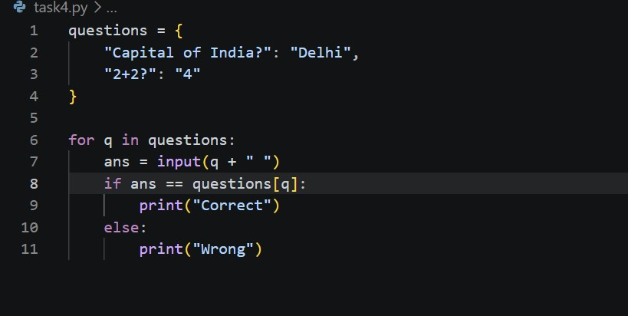
Output:
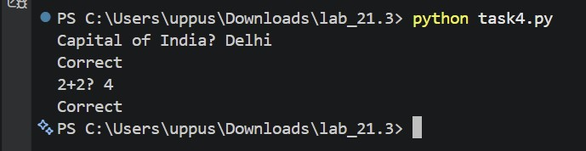
Explanation:
- tores questions and answers using a dictionary
- Loops through each question
- Takes user input
- Checks correctness and prints result Corrected Code:
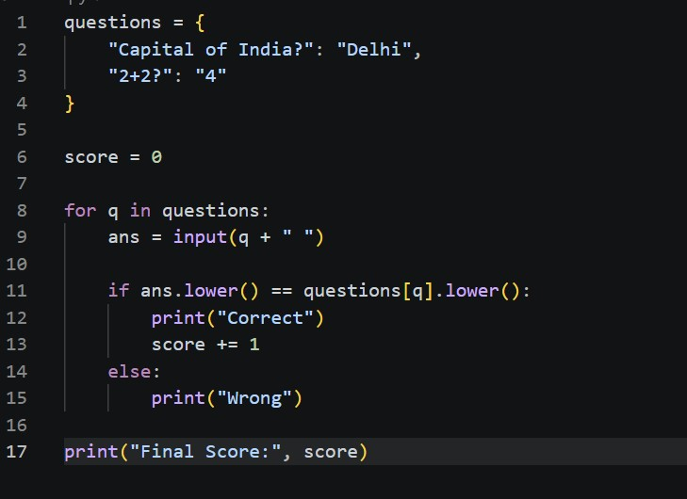
Output:
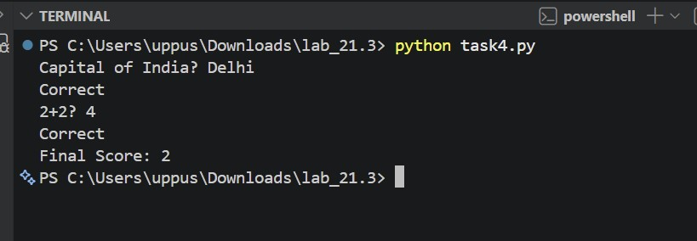
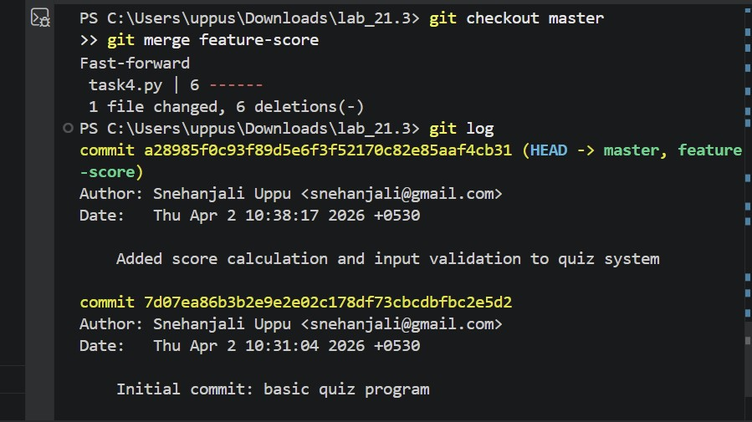
Explanation:
Basic quiz program was created (questions and answers)
Score calculation was added using AI assistance
Git was used to merge changes from branch to main

